<http://beagleboard.org/Support/bone101> more information about the pins on the beaglebone

good pictures of pins.

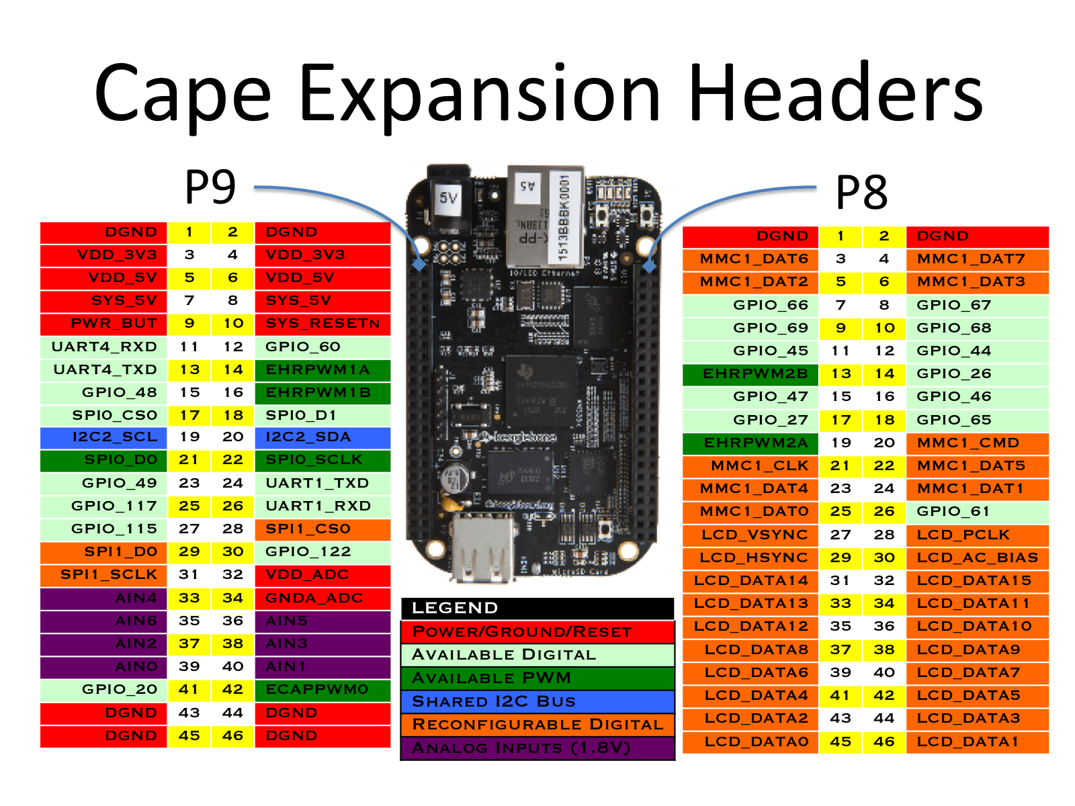

Installing & Enable BBB serial port:

<https://github.com/alexanderhiam/PyBBIO/wiki/Installing-PyBBIO>

BBB Device tree:

<https://learn.adafruit.com/introduction-to-the-beaglebone-black-device-tree/exporting-and-unexporting-an-overlay>